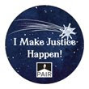

#2016 IMJH
Top Fundraising Firms

Total Raised during Pro Bono Month: over $12,000!

Week 4 (10/23 – 10/31)
total raised this week = $6,593
___________________________
1st Place: ***Ropes & Gray LLP ***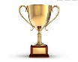
2nd Place: Morgan Lewis & Bockius LLP
3rd Place: Robinson & Cole LLP
4. Foley Hoag LLP
5. Choate Hall & Stewart LLP
5. Goodwin Procter LLP
5. Nixon Peabody LLP
6. Fragomen, Del Rey, Bernsen & Loewy LLP
6. WilmerHale LLP

Week 3 Results (10/17 – 10/24)
total raised this week = $2,785
____________________________
1st Place: ***Foley & Lardner LLP ***
2nd Place: Skadden, Arps, Slate, Meagher & Flom LLP
3rd Place: Mintz, Levin, Cohn, Ferris, Glovsky and Popeo, P.C.
4. White and Williams LLP
5. WilmerHale LLP
6. Goulston & Storrs PC
7. Robinson & Cole LLP
8. Foley Hoag LLP
9. Choate Hall & Stewart LLP
9. Goodwin Procter LLP
10. Ropes & Gray LLP

Week 2 (10/9 – 10/16)
Total raised this week = $2,455
____________________________
1st Place:*** Foley & Lardner LLP ***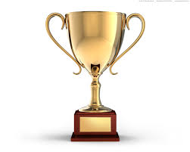
2nd Place. K&L Gates LLP
3rd Place. WilmerHale LLP
4. Goodwin Procter LLP
5. Robinson & Cole LLP
6. Ropes & Gray LLP
7. Skadden, Arps, Slate, Meagher & Flom LLP
7. Mintz, Levin, Cohn, Ferris, Glovsky and Popeo, P.C.

*anonymous donation of $50.

Week 1 (10/1-10/8)
Total raised this week = $360
____________________________
1st Place: ***Choate Hall & Stewart LLP ***
2nd Place. Robinson & Cole LLP
3rd Place. Ropes & Gray LLP
3rd Place. Skadden, Arps, Slate, Meagher & Flom LLP
3rd Place. WilmerHale LLP

